VEHICLE MANAGEMENT BY USING SALESFORCE

ACKNOWLEDGEMENTS

Our journey towards achieving the destination for the design and development of ‘This Project’ has finally come to a fruitful culmination. Our efforts and whole hearted cooperation of our lecturer has ended on a successful note. During this journey we faced numerous unforeseen problems and unknown challenges. Many people met us during this endeavour and enriched us with their support and knowledge both personally and professionally that resulted in the project being for better than it could possibly have been without them . We are deeply indebted to our teacher Anjaneyulu sir, whose inspiration and invaluable guidance has been unfailingly available to us at all stages of our practical .

PROJECT SELECTION

Today the world is considered as a competitive world where everybody seeks for accuracy in

least time. Earlier paper work was the means to keep various records. It was very time consuming and not even that accurate. So, we decided to design and develop the Project called VEHICLE MANAGEMENT SYSTEM which eliminates the paper work and provides better option to the people for their Vehicle records. It deals with the maintenance of the records of the different categories of vehicles and their owners. The user of this program can add records of the vehicles and their owners, view these records and can also edit them.

INTRODUCTION

The project ‘Vehicle Management System’ deals with the maintenance of the records of the different categories of vehicles and their owners. The user of this program can add records of the vehicles and their owners, view these records and can also edit them. This project is basically aimed for the Road and Transport Office which have large number of records of different types of vehicles to be maintained. The project makes it easier to search these records and edit them. The project has a very user friendly interface and all the operations that can be performed in the project are self explanatory. It reduces the effort required to manually maintain all these records. This project will really reduce the laborious record keeping.

USER MANUAL

### Creating Developer Account

Creating a developer org in salesforce.

1.Go to developers.salesforce.com/

2.Click on sign up.

3.On the sign up form, enter the following details :

 a.First name & Last name

 b.Email

 c.Role : Developer

 d.Company : College Name

 e.County : India

 f.Postal Code : pin code

 g.Username : should be a combination of your name and company

 This need not be an actual email id, you can give anything in the format : [username@organization.com](mailto:username@organization.com)

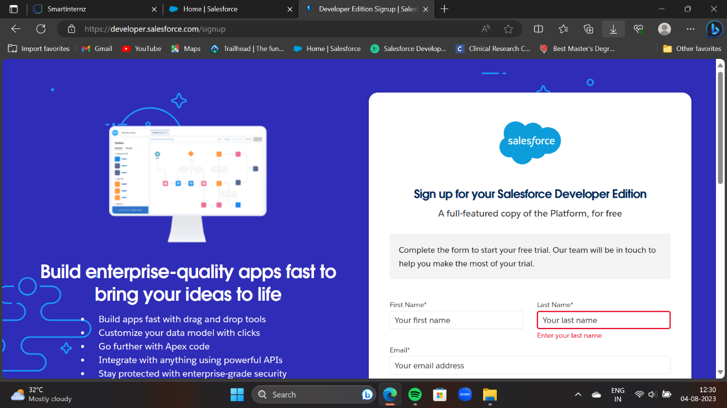

**To Create An Object**

The below steps will assist you in creating those objects.

* Click on the gear icon and then select Setup.
* Click on the object manager tab just beside the home tab.
* After the above steps, have a look on the extreme right you will find a Create Dropdown click on that and select Custom Object.

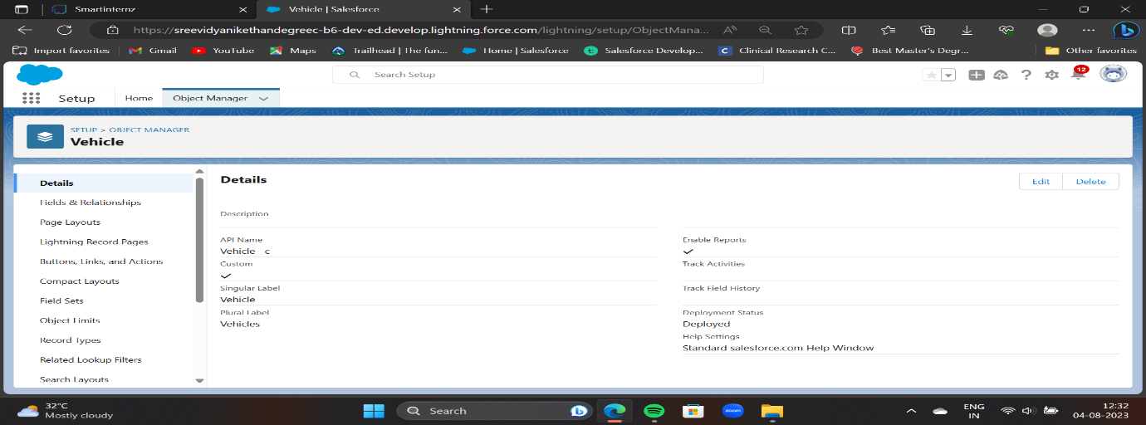

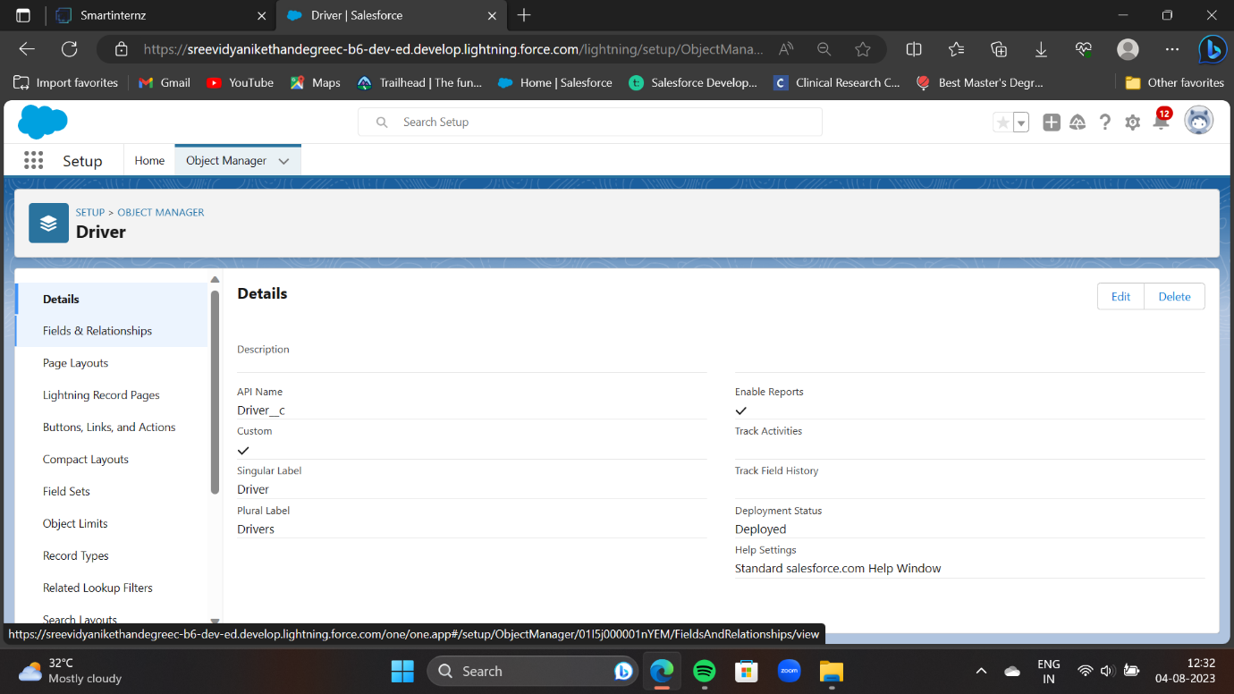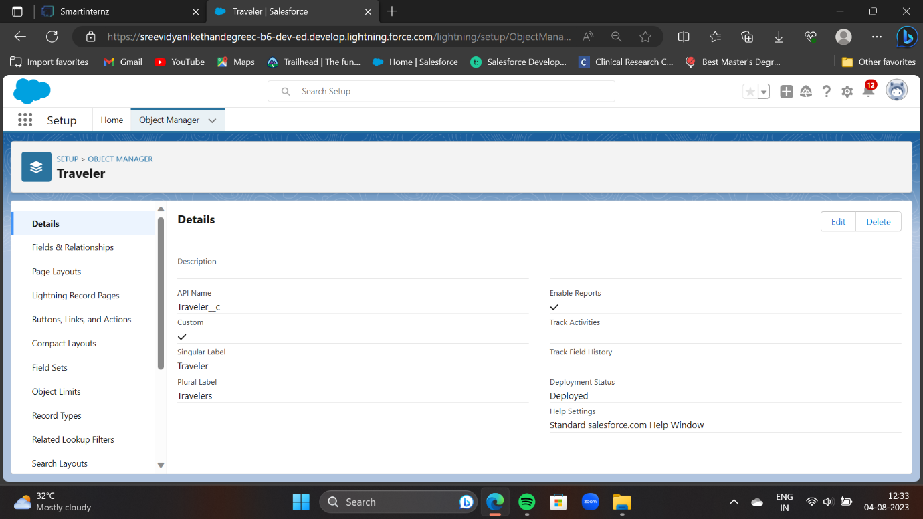

### Creation Of Fields

The below steps will assist you in creating Fields.

1.Click on the gear icon and then select Setup.

2.Click on the object manager tab just beside the home tab.

3.Search object (Vehicle) in quick find box.

4.Click fields & relationships and click new

5.Select any data type click next

6.Enter field label name and select next, next, and Save.

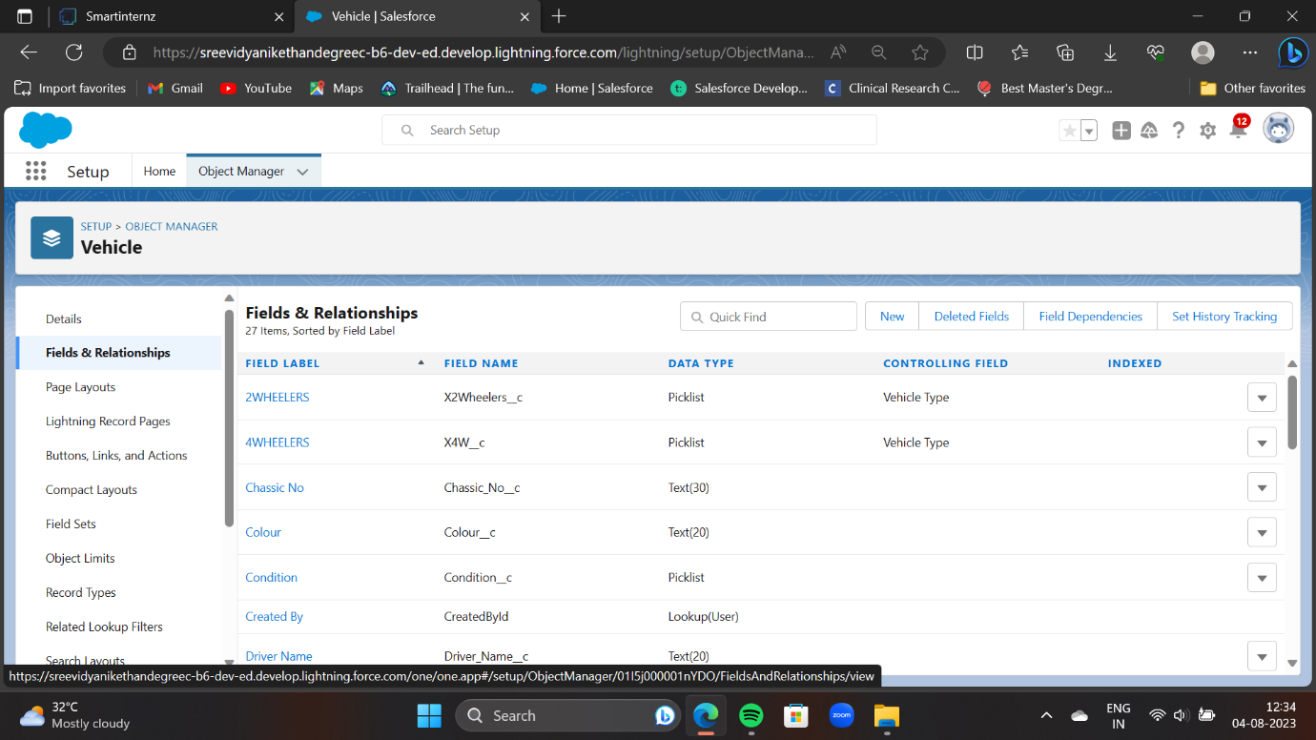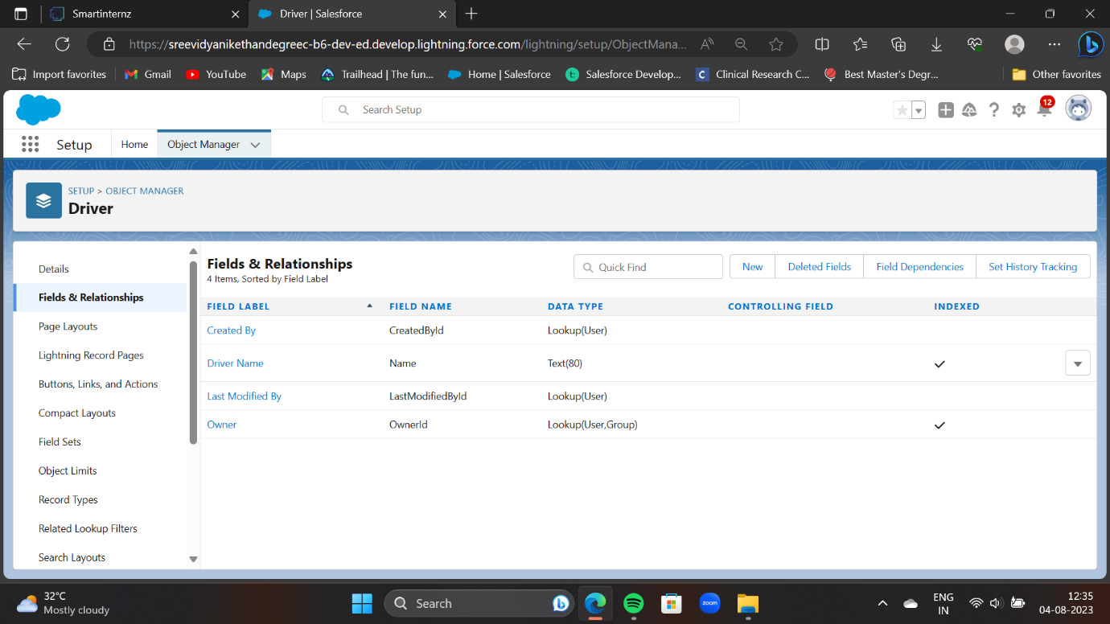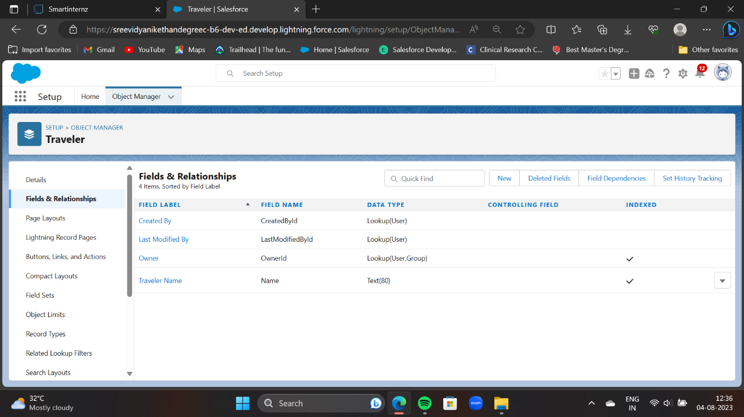

### Organize Opportunity Layout

1. Click on the gear icon and then select Setup.
2. Click on the object manager tab just beside the home tab.
3. Search in quick find (Opportunity) & select Opportunity.Click on page layout and you can add or remove fields by drag & dro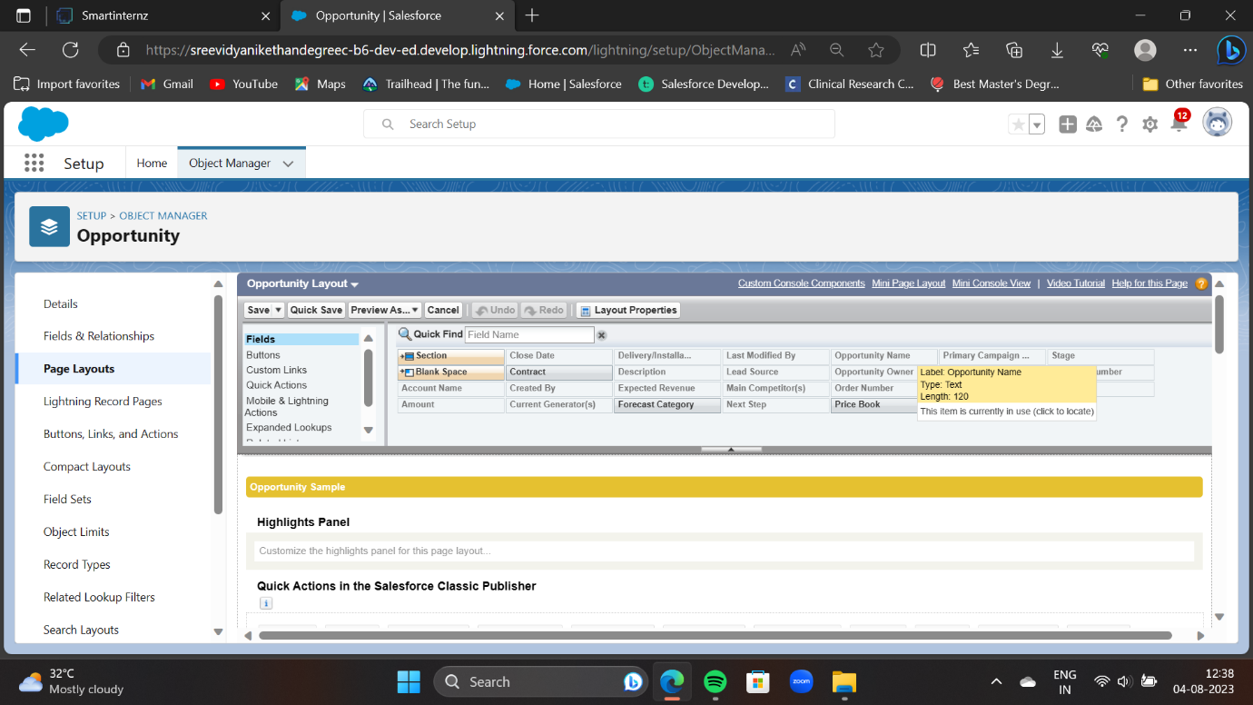

### Create The Vehicle Management App

1.From Setup, enter App Manager in the Quick Find and select App Manager.

2.Click New Lightning App. Enter Vehicle Management as the App Name, then click Next

3.Under App Options, leave the default selections and click Next.

4.Under Utility Items, leave as is and click Next.

5.From Available Items, select Accounts, Contacts, Opportunities, Vehicle, Driver, Travelers, Reports, and   Dashboards and move them to Selected Items. Click Next.

6.From Available Profiles, select System Administrator and move it to Selected Profiles. Click Save & Finish.

7.To verify your changes, click the App Launcher, type Vehicle Management and select the Vehicle Management app.

Note:

1.App Launcher-Displays available apps.

2.App Name-Displays the current selected app.

3.Navigation menu-Displays the tabs available inside the app

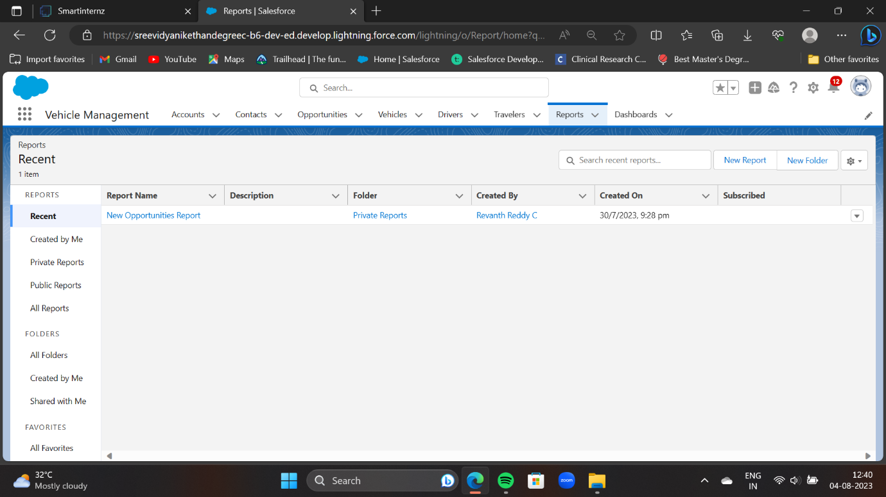

### Creating A Profile

Now create a Vehicle Manager profile and set its object permissions.

1.From Setup enter Profiles in the Quick Find box, and select Profiles.

2.From the list of profiles, find Standard User.

3.Click Clone.

4.For Profile Name, enter Vehicle Manager.

5.Click Save.

6.While still on the Vehicle Manager Profile page, then click Edit.

7.Scroll down to Custom Object Permissions and give access for

Create, Read, Edit, and Delete, View all and modify all for Vehicle object Driver object and Traveler object.

To create a new profile:

Go to setup -> type profiles in quick find box -> click on profiles ->clone the desired profile (standard user is preferable) -> enter profile name -> save

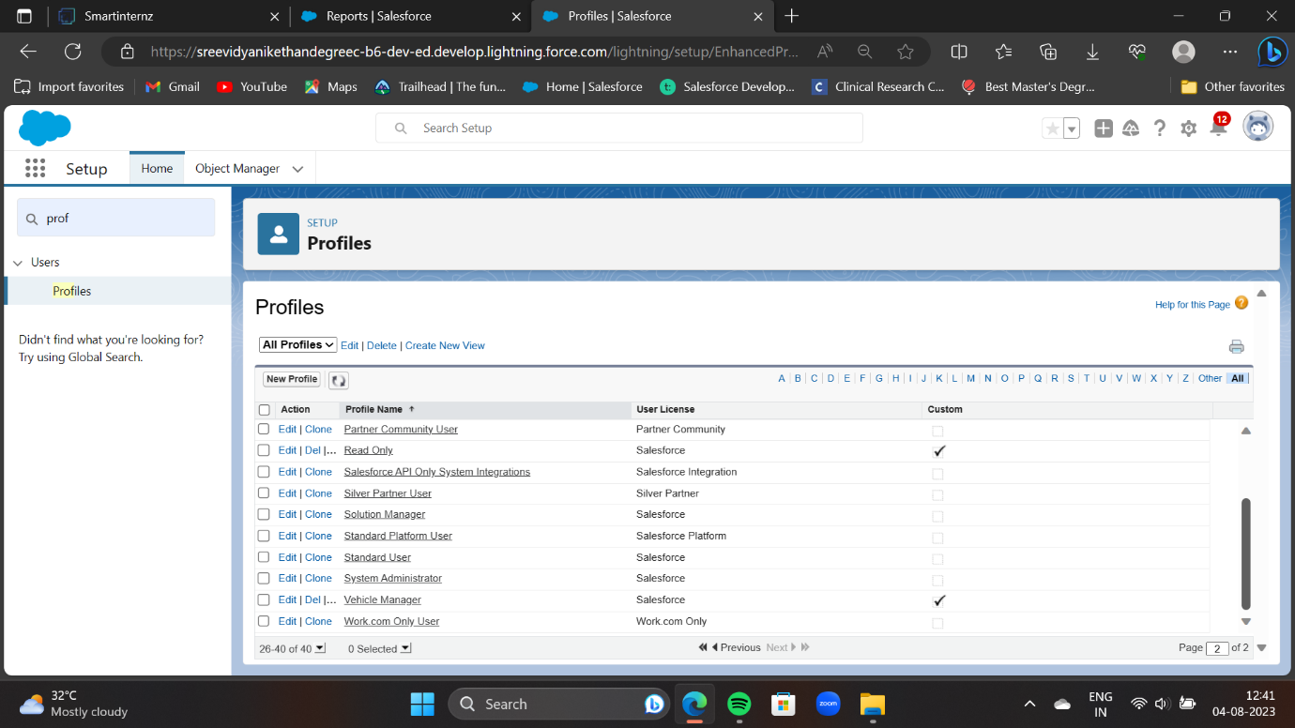

### Setup Roles

1.Click on the Gear Icon

2.Click "Setup"

3.In the Quick Find box, enter "Roles"

4.Click "Roles"

5.Click on "Set Up Roles"

6.Click "Expand All"

7.Under the CEO, click on "Add Role"

8.Fill up the Label as Vehicle Manager, Role Name Vehicle Manager.

9.Enter a Role name that will be displayed on Reports

10.Click on Save.

Similarly create Two Roles under Vehicle Manager as Operator 1 And Operator 2 Roles which will report to the Vehicle manager.

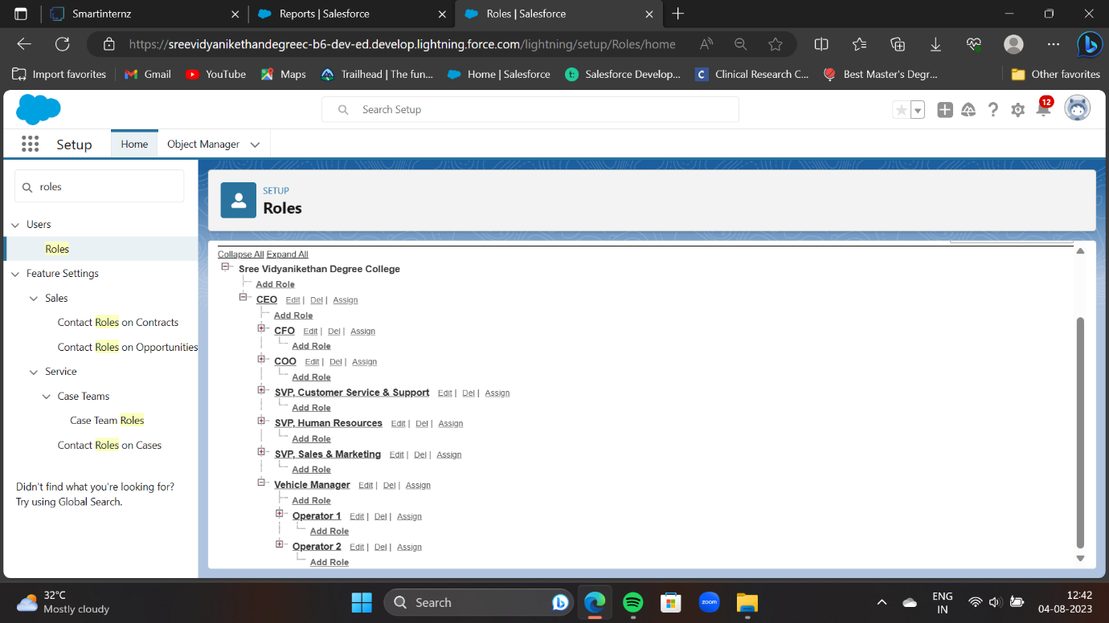

### Creating A User

1.From Setup, in the Quick Find box, enter Users, and then select Users.

2.Click New User.

3.Enter the user’s name John Teddy and (Your) email address and a unique username in the form of an email address. By default, the username is the same as the email address.

4.Select a Role(Vehicle Manager)

5.Select a User License As salesforce.

6.Select a profile as Vehicle Manager.

7.Check Generate new password and notify the user immediately to have the user’s login name and a temporary password emailed to your email.

8.Click On Save.

9.User will receive an email to reset password.

10.Once user will finish it, would be able to login and use the system.Similarly Create other 2 users and assign operator 1 and operator 2 roles along with operator profile.

### Create Vehicle Record

1.Click on App Launcher on left side of screen.

2.Search Vehicle Management System & click on it.

3.Click on Vehicle tab.

4.Click new button

5.Fill all Vehicle record details.

6.Click on Save Button

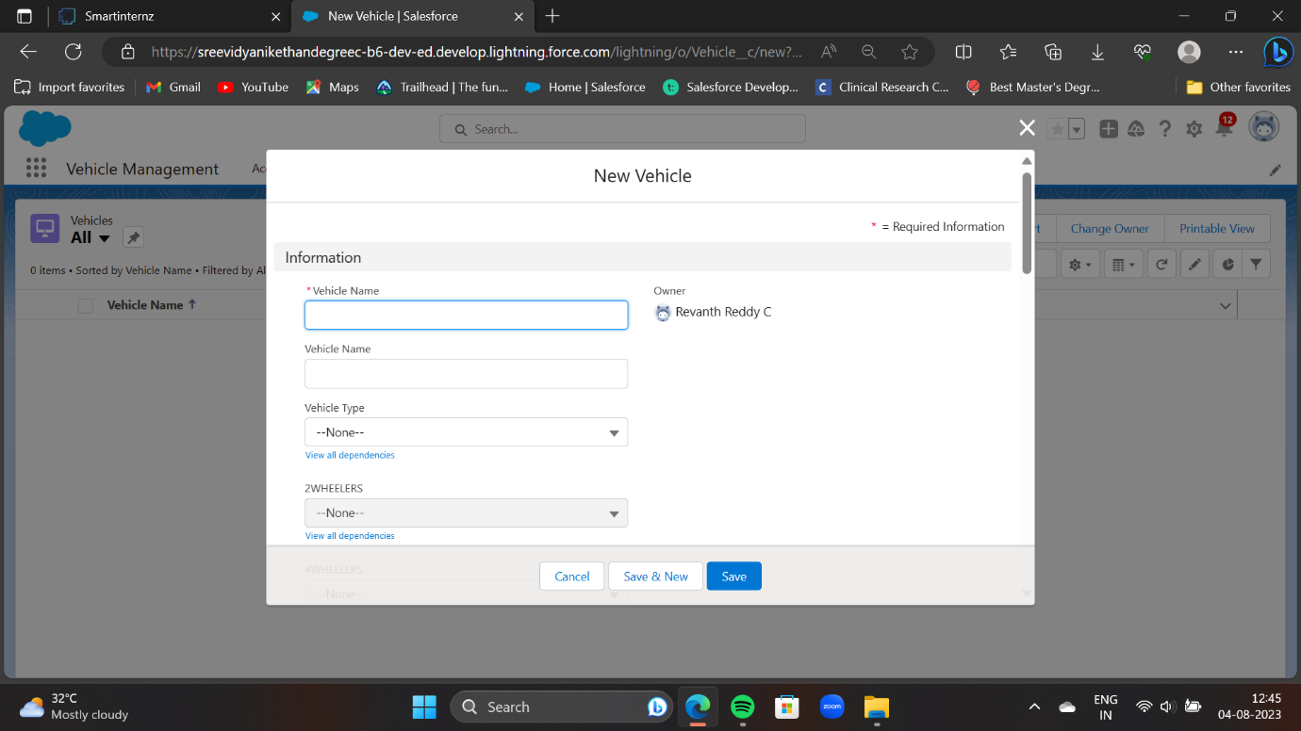

### Create Report

1.Go to Reports and click New Report.

2.Select the Opportunity and Customer Name report type and click Start Report.

3.To begin filtering, click Filters.

4.Click the Show Me standard filter and select All Opportunity. Click Apply.

5.Click on add columns add Opportunity: Opportunity name, Account Name, Amount, Traveler name etc.

6.Reports needs to be Grouped by one field.(ex - Created by )(require to enable add chart)

7.Click Save.

8.Save your report as Opportunity Details and accept the auto-generated unique name.

### Create Dashboard

1.Click the Dashboards tab.

2.Click New Dashboard.

3.Name the dashboard Opportunity Details and click Create.

4.Click +Component.

5.Select the Opportunity Details and click Select.

6.Select the Vertical Bar Chart component and click Add.

7.Click Save and then Done.

To create a report:

Go to the app -> click on the reports tab

### Report

1.Click on App Launcher on left side of screen.

2.Search Vehicle Management System & click on it.

3.Click on Reports Tab.

4.Click on Opportunity Details report and see records

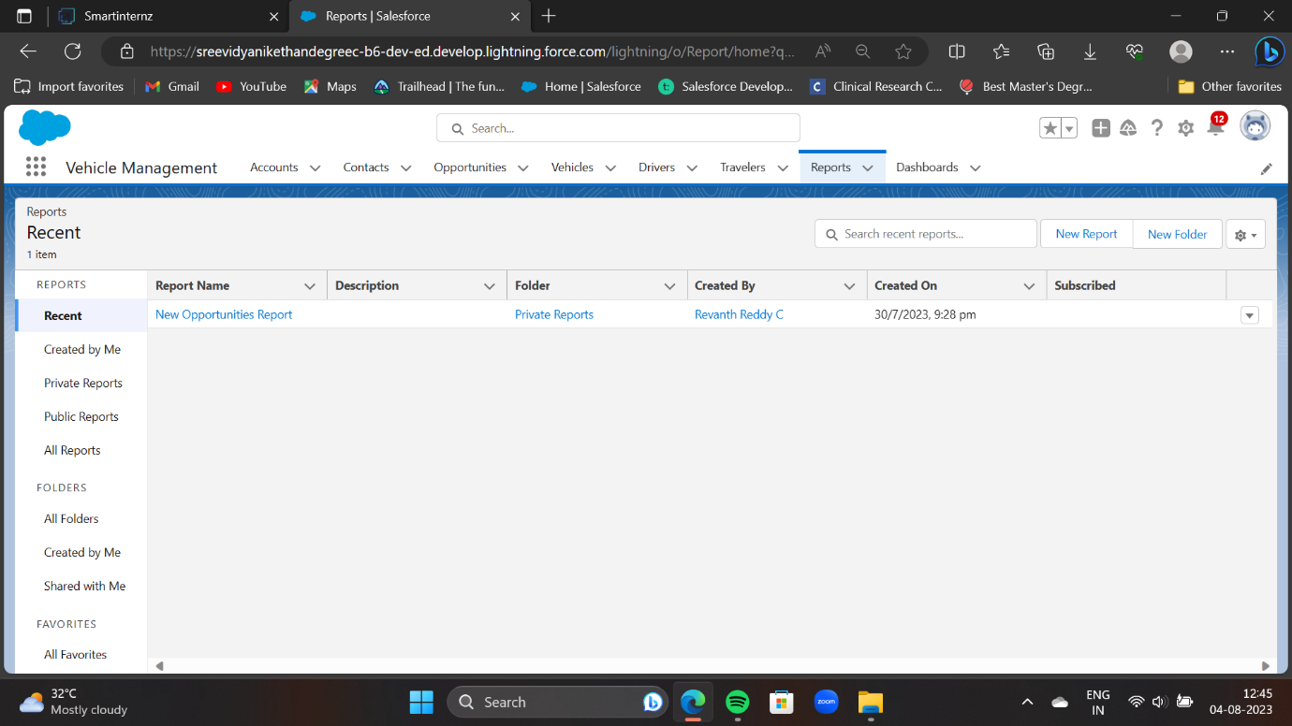

### Dashboard

1.Click on App Launcher on left side of screen.

2.Search Vehicle Management System & click on it.

3.Click on Dashboard Tab.

4.Click on Opportunity and Dashboard and see graph view of records

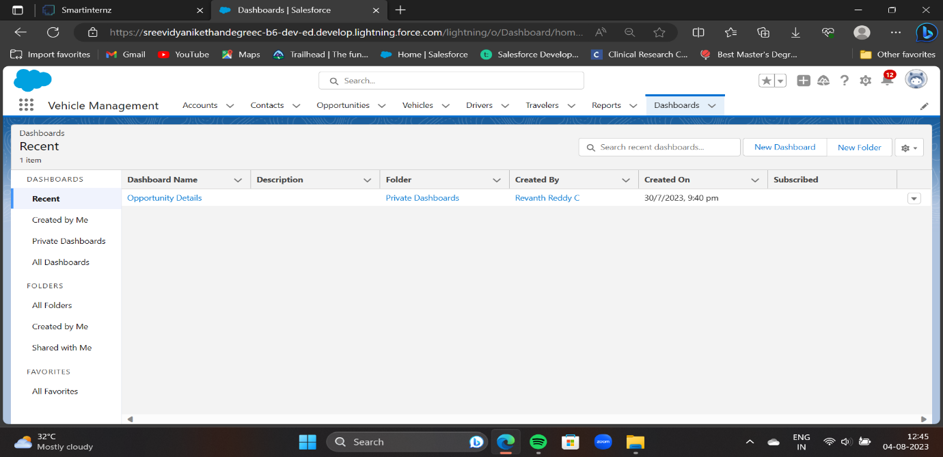

CONCLUSION

About project is only humble venture to satisfy the needs to manage their project work. Several user friendly coding have also adopted. This package shall prove to powerful package in satisfying all the requirements of the school. The objective of software planning is to provide a framework that enables the manager to make reasonable estimates made within a limited time frame at the beginning of the software and should be updated regularly at the project progresses. At the end it is concluded that we have made a effort on following points.

1. A description of the background and context of the project and its relation to work already done in the area.
2. Made a statement of the aims and objectives of the project.
3. The descriptions of purpose, scope, and applicability.
4. We define the problem on which we are working in the project.
5. We describe the requirement specifications of the system and the actions that can be done on these things.
6. We understand the problem domain and produce a model of the system, which describes operations that can be performed on the system.
7. We included features and operations in detail including screen layouts.
8. We designed user interface and security issue related to system
9. Finally the system is implemented and tested according to tes